Greentea peng – Mr sun
There is lots of elements of this music video that I like and want to implement into my own music video.
At the beginning of this music video, there is no music for the first few seconds, and this is accompanied by darkness in the set. The moment the music began the lights turned on in time with the beat. I want this to be something I use in my music video as I feel it is an effective way of keeping the video visually interesting and engaging right from the start. Whilst watching the video, I also noticed that the videos shown were not relating to the lyrics. I like how this felt relaxed and not too formal.
Most of the music video was outside and around nature which I like and wanted to be part of my own video. I think that being in fields and around trees and flowers is helpful to show carelessness and relaxation, which is a main theme I want to run in my own music video.
Greentea peng is wearing a bright and flowy outfit which I like (0.30). The bright colours are usually associated with happiness which helps to reinforce the theme I want to run throughout my own video. At various points of the video, the subject of the music video danced around with no care. I love how this looked, it wasn’t a uniform or rehearsed dance, it was just feeling the music and letting it control her body. I really want this to be part of my music video. It breaks up the video and looks freeing.
At points, there is what looks like camera equipment and tripods in the foreground of the video(1.07). I don’t want to add this into my music video as I think it looks messy and not put together. Whilst I want my video to look carefree and not overly rehearsed, I still want it to look clean and tidy. 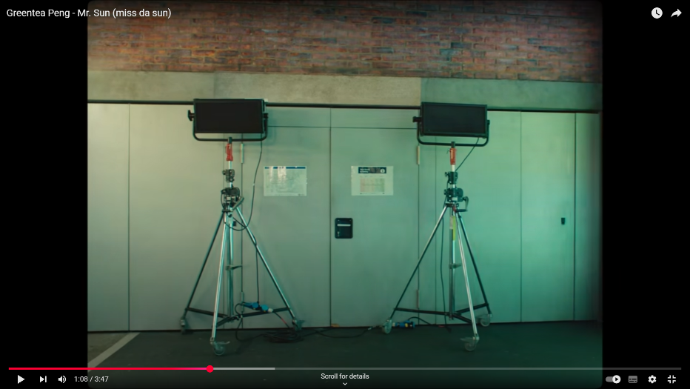
When dancing in fields, some clips of Greentea peng were slowed down (1.14). I think this enhanced the visual aspects and adds emotion to the clip. I want to take this effect and use it at points in my own music video. In the field, the sky was also altered. The colours were changed and made to look dystopian and fairylike. Whilst this was affective to change the mood and feeling of this scene, this is not something I want to include in my film. I want my film to be completely real with no use of green screens or distorting the visuals. I want to do this to keep it looking real, relatable and authentic.
During the Mr Sun music video, there was many different colour themes throughout. Sometimes, the main colours on screen were pinks, blues and purples (1.14). 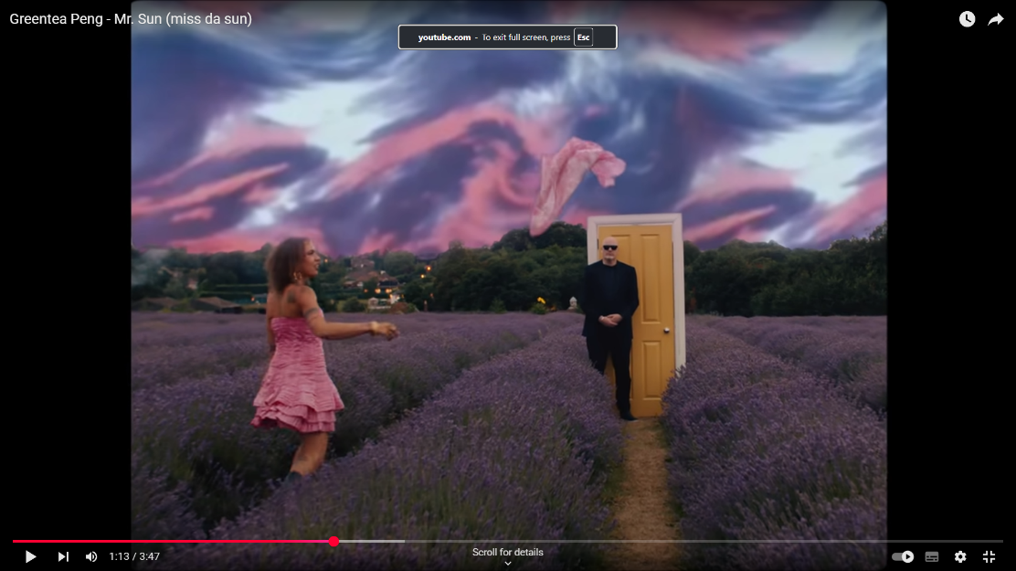
These colours have relations to love, care, tenderness, spiritual awareness and luxury. At other points, the main colours were dark green, black and grey (1.25).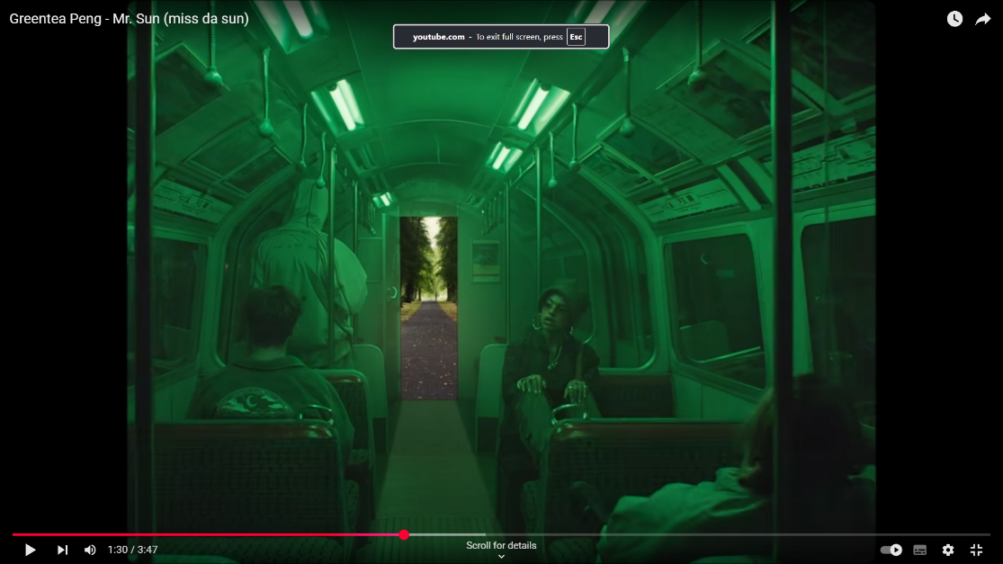
Contrary to the other clips, these colours are cool and more commonly associated with greed, envy, dullness and intimidation. Whilst I think this is affective to create contrast, I don’t want to incorporate this in my work. I want to keep my video light with mostly warm colours to create a feeling of happiness, comfort and strength.
GREENTEA PENG. (2019, October 2). Greentea Peng - Mr. Sun (miss da sun) [Video]. YouTube. https://www.youtube.com/watch?v=y_DDqg1A8lw

